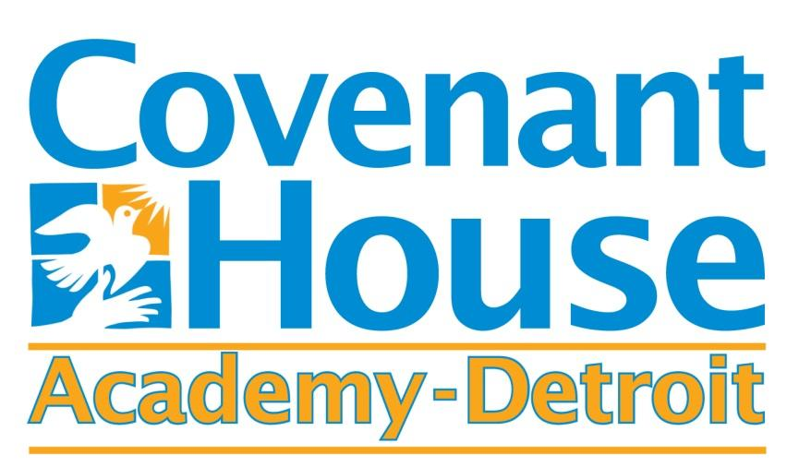

February 15, 2021:

Dear Parents and Community Members:

We are pleased to present you with the Annual Education Report (AER) which provides key information on the 2020-21 educational progress for the Covenant House Academy Detroit and our schools. The AER addresses the complex reporting information required by federal and some requirements of state laws. Our staff is available to help you understand this information. Please contact Tanya Duffy, Assistant Superintendent for help if you need assistance.

The DISTRICT AER is available for you to review electronically by visiting the following web site
https://bit.ly/3popoPw , or you may review a copy in the main office at your child’s school. Each school will also be communicating their own AER to parents directly.

These reports contain the following information:

Teacher Qualification Data
- Identifies the number and percentage of inexperienced teachers, principals, and other school leaders
- Reports teachers who are teaching with emergency or provisional credentials
- Includes teachers who are not teaching in the subject or field for which they are certified

NAEP Data (National Assessment of Educational Progress)
- Provides state results of the national assessment in mathematics and reading every other year in grades 4 and 8

Civil Rights Data
- Provides information on school quality, climate and safety
Review the table below listing our schools. For the 2020-21 school year, schools were identified using definitions and labels as required in the Every Student Succeeds Act (ESSA). A Targeted Support and Improvement (TSI) school is one that has at least one underperforming student subgroup. An Additional Targeted Support (ATS) school is one that has a student subgroup performing at the same level as the lowest 5% of all schools in the state. A Comprehensive Support and Improvement (CSI) school is one whose performance is in the lowest 5% of all schools in the state or has a graduation rate at or below 67%. Some schools are not identified with any of these labels. In these cases, no status label is given.

School Name | Status Label | Key Initiative to Accelerate Achievement
Covenant House Southwest | No Label | Expanded Guided Study program to increase engagement and academic support
Covenant House Central | No Label | Expanded Guided Study program to increase engagement and academic support
Covenant House East | No Label | Expanded Guided Study program to increase engagement and academic support

I would like to thank the entire staff of Covenant House Academy Detroit for their continued commitment to our mission. This year has presented unprecedented challenges for education and our students and families have been greatly impacted by the pandemic. All staff pulled together to help students secure technology, connectivity, food assistance, and stay connected to school. Despite all of these challenges, we have continued to help students progress on their path to achieve their diplomas. Covenant House Academy is proud of the relationships we have built with students and families. These relationships help us connect our students to valuable resources in our community. We are grateful to our parents and students who continue to trust Covenant House Academy to assist them in achieving their educational goals.

Sincerely,
Terrence M George, Superintendent

