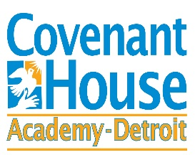

March 11, 2020

RE: COVID-19 Health Information

Dear Students, Parents and Guardians:
CovenantHoueAcademy.org
As of March 11, 2020, Michigan has two confirmed cases of COVID-19. Covenant House Academy is receiving and following guidance from local and state health departments, the Centers from Disease Control, and the Michigan Department of Education.
We want to remind you that the best ways to prevent the spread of COVID-19 are the same as preventing the cold and flu, and include:
- Frequently washing your hands with soap and water
- Covering your mouth when you sneeze or cough
- Avoiding touching your eyes, nose, and mouth
- Cleaning and disinfecting frequently touched objects and surfaces using a regular household cleaning spray or wipe
- Avoiding close contact with people who are sick
- Staying home when you are sick
- Practicing good health habits:
  - Get plenty of sleep
  - Be physically active
  - Manage your stress
  - Drink lots of water
  - Eat nutritious food
We will continue monitoring the development of COVID-19 and plan accordingly in partnership with local, state, and federal health officials. We are already taking the following steps:
- We are encouraging students and staff throughout the district to increase handwashing efforts in order to decrease the spread of illness.
- We have increased cleaning/disinfecting efforts within the district as recommended by the CDC; this includes increased cleaning of frequently touched surfaces.
The safety, health and well-being of our students and staff continue to be our top priority. We will monitor the situation closely and notify you of any changes in our response to the situation.
Sincerely,
Terrence M. George
Superintendent

